# # Unit 14 Sequelize Homework: Reverse Engineering Code

* This application uses three-tier architecture and full stack development.
* The server.js is like the mother board on physical computer. It connect all part of the fullstack application.
* 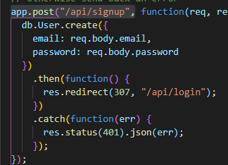Both HTML and API routes are map for all URL path i.e.
* HTML files are part of the presentation layer. It has the HTML to handles all users requests and receive responses from the databse via the middleware.
* Passport is the responsible to authenticate users and control permissions and authorization to part of the application
* 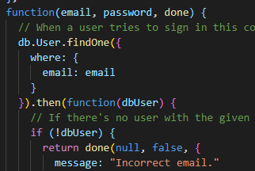
* The models provide functions to handle data. 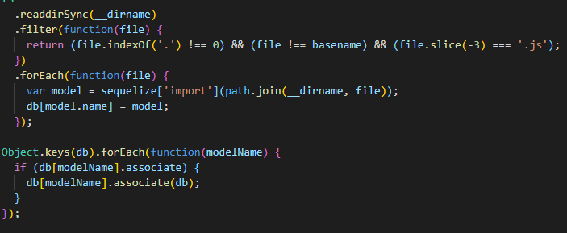
* Condfig.json contains information about database login credential, database name and host.
* IsAuthenticated.js is utility function that return whether the user is login in or not.